EXPT NO:4 | TRANSFORM DATA TO SUIT BI REPORTING REQUIREMENTS AND  DESIGN A DASHBOARD WITH KEY PERFORMANCE INDICATORS (KPIs ) USING TABLEAU AND POWERBI
DATE: 24.07.2026

PRE-LAB QUESTIONS (PROVIDE BRIEF ANSWERS TO THE FOLLOWING QUESTIONS) :

- What is the role of data transformation in BI reporting?
Data transformation converts raw, inconsistent data into clean, structured, analysis-ready data. It involves merging sources, fixing data types, creating calculated fields, and reshaping data. Without it, dashboards would show inaccurate or unreliable numbers — it's the foundation that makes reporting trustworthy.
- What are the common data cleaning techniques in Tableau and Power BI?
Power BI uses Power Query to remove duplicates, fix data types, and handle nulls. Tableau uses Data Interpreter and Data Prep to clean headers, split fields, and group values. Both support filtering and pivoting data. Goal: standardized, noise-free data.
- How do Tableau and Power BI handle data aggregation?
Power BI uses DAX formulas like SUM and AVERAGE for precise control. Tableau auto-aggregates fields visually, switchable via dropdown. Both recalculate dynamically with filters. Tableau is visual-first; Power BI is formula-first.
- What are KPIs, and why are they important in a dashboard?
A KPI is a measurable value showing performance against a goal, like revenue or churn rate. It cuts through data clutter to highlight what matters most. KPIs show quickly if performance is on or off track. They help teams align and decide faster.
- What are the different types of charts available in Tableau and Power BI for visualization?
Both offer bar, column, line, and pie charts for comparisons. Scatter plots, bubble charts, and treemaps show relationships and composition. Maps handle geospatial data in both tools. Advanced options include heat maps, waterfalls, and KPI cards.

IN-LAB EXERCISE:
OBJECTIVE:
To transform COVID-19 data into a structured format suitable for Business Intelligence (BI) reporting and design interactive dashboards with Key Performance Indicators (KPIs) using Tableau and Power BI.
PROCEDURE:
- Data Collection:
  - Import the COVID-19 dataset from inbuilt sources like Our World in Data or CSV files containing country-level COVID statistics (e.g., new cases, deaths, vaccinations).
  - Datasets may include fields such as date, location, new_cases, total_cases, new_deaths, total_deaths, people_vaccinated, etc.
- Data Cleaning and Transformation:
  - Convert columns like date to proper date formats.
  - Handle missing or null values in new_cases, total_cases, etc.
  - Create calculated fields (e.g., daily case growth rate, case fatality rate, vaccination percentage).
- Data Aggregation:
  - Aggregate data by continent, country, or month.
  - Use measures like SUM(new_cases), AVG(positivity_rate), MAX(total_deaths).
- Designing KPIs:
  - Identify KPIs such as:
    - Total Confirmed Cases o Total Deaths o Case Fatality Rate o Vaccination Coverage (%)
    - Daily Case Growth Rate
  - Use DAX (Power BI) or Calculated Fields (Tableau) to compute and visualize these KPIs.
- Dashboard Development:
  - Build visualizations such as:
    - Line charts for daily new cases and deaths o Bar charts for country-wise vaccination progress o Maps to show regional case distribution
    - KPI cards for high-level insights
  - Use filters (e.g., by continent, country) and slicers (e.g., by date range) for interactivity.
- Publishing and Sharing:
  - Publish the dashboard using Tableau Public/Server or Power BI Service.
  - Share the dashboards with stakeholders through public or organizational portals.
Experiment Dataset: COVID-19 Global Dataset
Fields Used:
  - Date – Date of the report
  - Location – Country or region
  - New Cases – Daily reported cases
  - New Deaths – Daily reported deaths
  - People Vaccinated – Cumulative vaccinated count
  - Total Cases – Cumulative confirmed cases
  - Total Deaths – Cumulative deaths
  - Population – Total population of the country

POWER BI DASHBOARD:
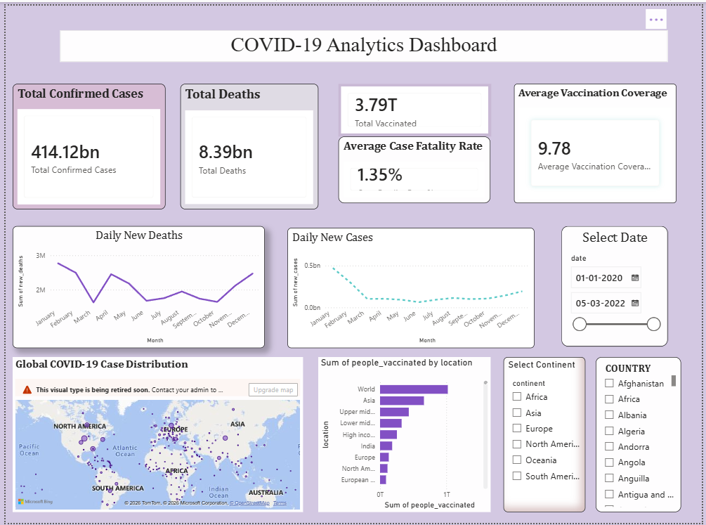

TABLEAU DASHBOARD:
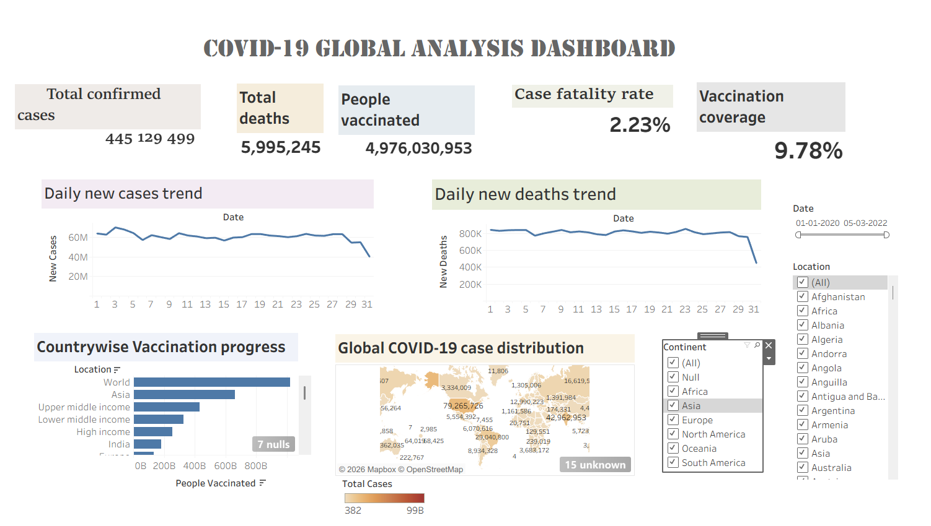

POST-LAB QUESTIONS (PROVIDE BRIEF ANSWERS TO THE FOLLOWING QUESTIONS)
  - How did data transformation improve the quality of insights in your COVID-19 dashboard?
Standardizing dates, region names, and case counts fixed inconsistencies across sources. Removing duplicates and creating calculated fields, like rolling averages, made trends easier to spot. This turned raw numbers into reliable, meaningful insights for tracking the pandemic's progression.

  - What challenges did you encounter during the data cleaning process, and how did you resolve them?
Missing values and inconsistent region naming caused mismatches during merging. I standardized naming conventions and handled nulls through imputation or exclusion where needed. Duplicate entries were removed using unique identifiers to ensure accurate counts.

  - Which KPI provided the most valuable insight, and why?
The 7-day rolling average of new cases was most valuable, as it smoothed out daily reporting noise. It gave a clearer trend direction than raw daily counts, which were skewed by reporting lags. This made it the key metric for planning decisions.

  - How does interactivity in dashboards improve user experience?
Interactivity lets users filter by region, date, or category to explore data relevant to them. Drill-downs and tooltips add context without cluttering the view. This makes the dashboard feel personalized and helps users find answers faster.

  - What steps would you take to further enhance the dashboard’s effectiveness?
Adding predictive analytics would help forecast future trends rather than just reporting past data. Real-time data feeds would keep information current, and better mobile responsiveness would widen accessibility. Gathering user feedback would also help prioritize the most useful metrics.

RESULT:

The COVID-19 dataset was successfully cleaned, aggregated, and transformed for visual analysis using Tableau and Power BI. Missing values, data type mismatches, and inconsistencies were addressed. KPIs such as vaccination rate and daily case growth offered valuable insights into the pandemic trends across countries and timeframes. The resulting interactive dashboards allowed for effective public health monitoring and communication.

ASSESSMENT

Description |  | Max Marks | Marks Awarded
Pre Lab Exercise |  | 5
In Lab Exercise |  | 10
Post Lab Exercise |  | 5
Viva |  | 10
 | Total | 30
 | Faculty Signature

